Pro Tour-New Orleans Preview
Gary Wise
It's always been Chicago. For years, the first individual Pro Tour of each new season has taken place in Chicago, and the memories have persisted: Randy Buehler's winning his first Pro Tour and Dirk Baberowski doing the same the next year; Bob Maher's fantastic win and the following embrace from his future wife, and most recently, the beginning of Kai Budde's dominance of the Pro Tour one year ago. With the end of the Chicago era goes the cold, the wind, and a lot of great memories...

Over the last year, Budde has been as close to unstoppable as any player has been in the history of the game.
...Which isn't so bad when replaced with Louisiana warmth and Bourbon Street. Welcome to New Orleans, home of jazz, party and the celebration of life itself. There's a good reason that the Super Bowl is held here every three years: No city can match the good-hearted, good-time, love-of-life attitude of this 24-hour party town that welcomes all strangers to come and have a drink. Enter the Pro Tour.
This year's Midwestern PT will be a study in evolution, both of the Pro Tour and the Extended format. With Worlds having included Extended this year, the format's base is firmly established, and it's up to the competitors to determine two things: how the metagame will shift and what effects Odyssey will have on the environment.
The question is whether any of the cards contained within Odyssey will affect any of the many existing archetypes, or better yet, create a few new ones. That question can only be answered by the players and their results, but the players will be busy trying to answer another question: Who can stop Kai Budde?
Over the last year, Budde has been as close to unstoppable as any player has been in the history of the game. After his win in Chicago a year ago, Kai went on to post victories at PT-Barcelona, GP-London and PT-NY, where he shared the win with Dirk Baberowski and Marco Blume, and hasn't shown any signs of slowing down. Backed by Team Godzilla, considered by some to be the planet's strongest team (while others back ABU on this debate), Kai's considerable play skill and commitment are always backed by the finest selection of decks in the game, and that's pretty difficult to put the whammy to.
So who seems most likely to put an end, even if only temporary, to Kai's little string? I've compiled a list of the most likely candidates:
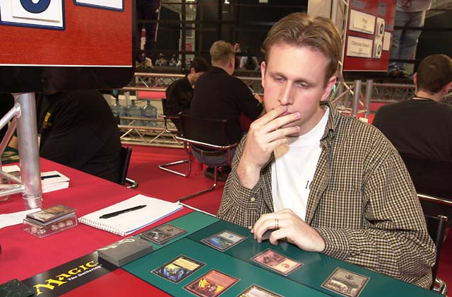
Bob Maher - It's been a while since the last Extended Pro Tour, but back in December of 1999, Bob Maher changed his Pro Tour status from has-been (his own words) to superstar, notching a victory in Chicago that proved decisive in that year's Player of the Year race. Playing his now famous Oath deck, Bob cut a path through the opposition, defeating a now-defunct Necro-based archetype in the final. Whether he'll be able to play Oath again is questionable (he played a Recur-Survival deck in the Masters at PT-NY 2000), but surrounded by a number of strong pro players in Madison, Wisconsin and possessing strong contacts in the Jumble, you can be sure that he'll be playing a strong deck backed by formidable knowledge of the format and play skill to boot.
ABU - One of the two strongest forces on tour right now, ABU's history suggests that Limited play is their forte, but at the last Constructed Pro Tour, that all changed as four players using their deck made the Top 8 at Tokyo: the strongest showing by any one team in the history of the game. Ryan Fuller went 14-0 in the Swiss while Chris Benafel and Lucas Hager both made it to the semifinals in a show of force that propelled this team right to the top. With such luminaries as Antoine and Olivier Ruel, Benafel, Fuller, Noah Boeken, Brian Hegstad, Phil Freneau and perhaps the best of them all, team associate Kamiel Cornelissen, ABU has to be considered a force to be reckoned with at any Pro Tour: Now we'll see if they can follow up on Tokyo.
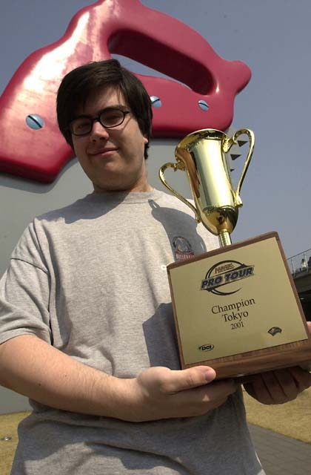
Godzilla - As if Kai Budde wasn't enough, the rest of Godzilla is pretty tough as well. Despite ABU's dominance in Tokyo, none of them even made it to the final, where it was Constructed specialist Zvi Mowshowitz who took home the big prize. Mowshowitz and his partner in crime Scott Johns have long been one of the most formidable deck building teams in the game, and now, having teamed with the German duo of Budde/Patrick Mello, the Hampton Court trio of Ben Ronaldson/John Ormerod/Gary Wise and other top pros like Alan Comer, Ben Klauser and Brian Selden, they're primed to fulfill the promise that the members of this team make when calling themselves full-time Magic players.
Jon Finkel - With Kai doing what he's been doing, it's easy to remember that before him, there was another guy hanging around who wasn't doing too badly in professional Magic tournaments. Finkel's 'off year' last season included two Top 8's, a Master's final and a Master's semifinal, and until a poor performance on Day 3, looked like it would include his second straight Worlds Top 8. Of course, the format of Day 3 was Extended, but now he'll have an opportunity to pick and choose from the best of those decks played in Toronto, and that means he'll be able to let his unsurpassed play skill take over. That could be bad news for the rest of the Pro Tour.
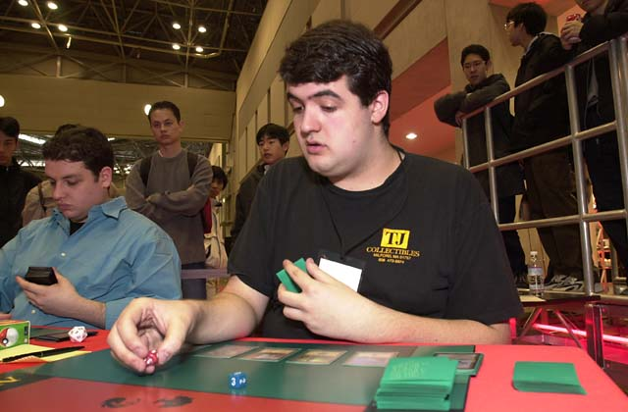
Billy Jensen - While Maher won the last Extended Pro Tour, since then there's been one premier level Extended event: The Masters at 2000 PT-NY, and it was Baby Huey who won the whole thing with the now-defunct Tradewind-Survival archetype. Jensen hasn't had the best of seasons, but his taking home the $25,000 first prize in an Extended tournament just over a year ago gets him on this list by default. Look for Jensen, who built the deck played by the majority of the Jumble at Worlds, to show up with something a little different this time, with teammates Ben Rubin and Brian Kibler on the case, trying to find something new to destroy the opposition.
Mike Turian - With Aaron Forsythe's recent departure from the team, Mike Turian is now the undisputed leader of Team CMU. Carrying with him the label of "Limited specialist", Turian's been excelling in all formats as of late, with his win at GP-Montreal following his quarterfinal finish at Worlds. In Toronto, Mike played Secret Force, going an impressive 5-0-1 (Thanks in part to Alex Borteh's concession), propelling himself into the Top 8: not too shabby for a 'Limited specialist'. Now the question is whether his recent hot streak and new leadership role will translate into Extended success. Tune into the Sideboard's coverage this week to find out.

